

Roles and Responsibilities

Purpose

This document provides an overview of the various functions performed by local authority and HM Land Registry (HMLR) personnel during migration of the Local Land Charges (LLC) service.

Who is it for?

Local authority
Senior Responsible Owner, Operational Lead and Local Land Charges Officer

Local authority

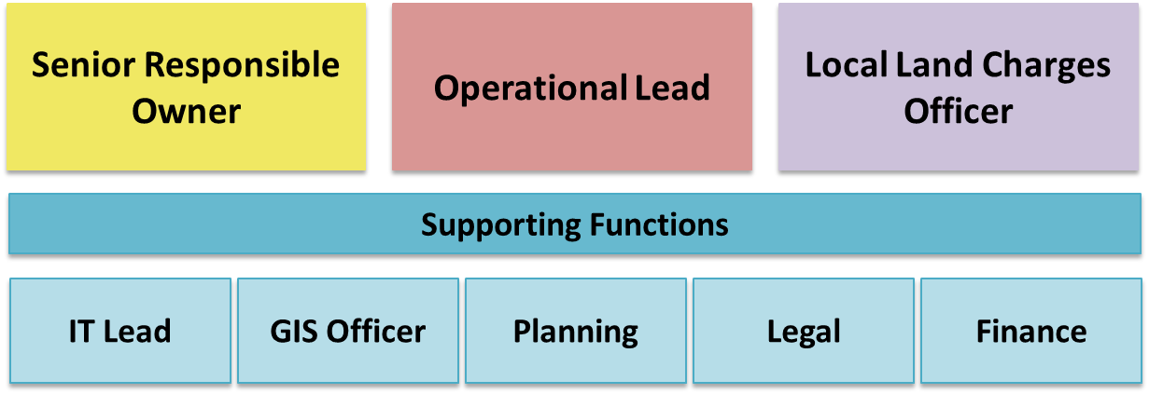

Role | Responsibilities
Senior Responsible Owner | Leads the strategic oversight of the migration  Makes strategic decisions on behalf of the local authority  Ensures the local authority fulfils its responsibilities to agreed timescales  Ensures the migration is considered in the wider local authority context  Feeds back on progress to all stakeholders including HMLR  Raises awareness of the support infrastructure provided by HMLR
Operational Lead | Primary contact within the local authority  Works closely with the HMLR Delivery Manager  Ensures migration activities delivered to time  Provides detailed insight into the service, people, data and processes  Deploys resource  Engages all necessary support functions as required
Local Land Charges Officer | Undertakes migration activities  Responds to data-related queries  Provides insight into current LLC processes  Continues to deliver the LLC service through migration
IT Lead | Enables extraction of data  Provides information on IT architecture, software and processes  Sets up Secure File Transfer Protocols (SFTP)  Implements system-related upgrades
GIS Officer | Provides information on and access to spatial data
Planning Officer | Provides information on and access to planning data and processes  Responds to data issue enquiries  Effects amendments to local authority data
Legal | Main contact for legal matters including consideration of the Collaboration Agreement and HR-related matters
Finance | Provides information on financial charge-related data and processes  Responds to data issue enquiries

HM Land Registry

Local Authority Delivery Manager

Supporting Functions

Customer Delivery Manager
Business Analyst
Data Quality Analyst
Technical Delivery Manager
Lawyer

Role | Responsibilities
Local Authority Delivery Manager | Main contact within the Programme  Works closely with the local authority Operational Lead  Project manages the end-to-end delivery from pre-migration to go-live  Coordinates HMLR subject matter expertise
Customer Delivery Manager | Raises awareness of the Local Land Charges service with customers  Leads launch event planning  Account manages volume Local Land Charges customers
Business Analyst | Works with local authorities and suppliers to deliver digitisation and transformation of local authority data  Undertakes analysis of local authority data to determine compatibility with HMLR’s LLC Register  Works with local authority Local Land Charges teams and HMLR Local Authority Delivery Managers to enhance local authority data to meet HMLR’s LLC Register requirements
Data Quality Analyst | Evaluates data output against pre-defined standards and data specifications  Develops and reviews technical solutions to enable standardised quality assessments to be carried out against bulk data sets  Assimilates and reports on output from quality assessments to give assurance quality is being maintained at the correct level
Technical Delivery Manager | Supports local authorities in the extraction of Local Land Charges data  Works closely with local authority IT Leads  Establishes a community of best practice amongst local authorities and other originating authorities  Assists in the engagement with and management of incumbent suppliers  Works closely with the Local Authority Delivery Manager
Lawyer | Provides legal support on policy, commercial and migration matters  Primary Programme contact for Collaboration Agreement queries

Any questions?
llcproject@landregistry.gov.uk

